Sonic Bothy is seeking a Treasurer to join its board and support our organisation
Treasurer Application Pack
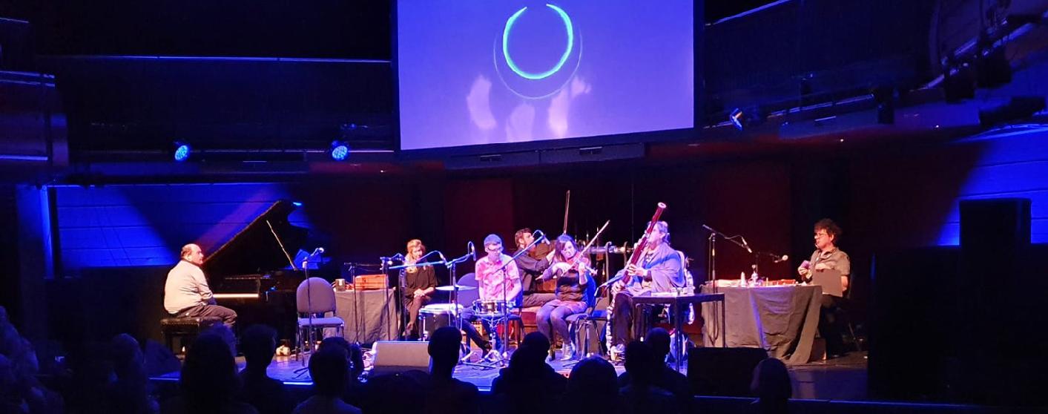
Sonic Bothy is an inclusive new music organisation. Our vision is to create opportunities for disabled musicians to individually create, perform and collaborate in making original new and experimental music.
We seek ways to collaborate on a truly equal footing within mixed ability ensembles. We wish to realise the significant contributions disabled musicians can make to sound, art and music culture, and to celebrate and promote music created by individual artists and mixed ability groups. More information is available here
We are going through an exciting phase of growth and development, as an organisation and as a board. To support us through this phase we want to recruit a Treasurer to join the board.

The Treasurer Role
The Treasurer helps us to continue to develop good financial governance, maintains an overview of Sonic Bothy’s affairs and confirms that proper financial records and procedures are maintained. The Treasurer has specific responsibilities as a Trustee of Sonic Bothy. These are explained under Duties.
Skills and Experience Required
You will have financial management knowledge and skills and will be able to bring your expertise to this vital role and work alongside existing and future Trustees. You might be an accountant or have financial management skills and knowledge through work in a financial role within a private or public sector organisation, the third sector, or running your own business.
Our new Treasurer should have an interest in music / arts / culture and participatory and socially-engaged work and recognise the impact that it can have on people’s lives. You do not need to have previous experience in these areas or have had previous experience on a Board.
All day to day financial management is completed by Sonic Bothy staff, who work alongside our accountants The Kelvin Partnership.

Time Commitment
The board meets a minimum of four times per year with meetings usually falling in March, June, September and December in addition to an AGM. Board trustees may also be expected to give some extra time in support of the organisation’s activities by participating in sub-committees, research etc. Sonic Bothy performs around six times per year (in normal circumstances) and board members are expected to attend a minimum of two performances.
Location: At present board meetings are virtual, however we plan for some meetings during the year to return to in person, usually meeting in Glasgow or Edinburgh.
Remuneration: This is a voluntary, unpaid position, however the cost of travel to and from in person board meetings from within Scotland will be paid.

Duties of the Treasurer
- With the wider board, ensure that the financial resources of the organisation meet its present and future needs.
- Ensure that appropriate accounting procedures and controls are in place.
- Review budgets, management accounts and financial statements prior to submission to the board and independent reviewers, ensuring accurate reporting of the state of the company finances.
- Ensure that the accounts are prepared and disclosed in the form required by funders and the relevant statutory bodies, for example OSCR and that the accounts are scrutinised in the manner required (independent examination or audit). With the wider board ensure any recommendations are implemented.
- Support trustees to understand financial information being presented to the board and its relevance to the business.
- Advice on aspects of the financial implications of the organisation’s strategic plans.
- Keep the board informed about its financial duties and responsibilities and help the board to develop its financial governance and understanding.
General Duties of a Trustee, alongside your Co-Trustees, are to:
- Seek, in good faith, to ensure that Sonic Bothy operates in a manner that is consistent with its objectives and that Sonic Bothy applies its resources exclusively in pursuance of its stated aims.
- Act in the interests of Sonic Bothy and serve as an advocate for the organisation as required, including for specific issues or events.
- Act with the care and diligence that it is reasonable to expect of a person who is managing the affairs of a SCIO.
- Ensure that Sonic Bothy complies with the provisions of the Charities and Trustee Investment (Scotland) Act 2005, its governing documents and any other relevant legislation or regulations.
- Contribute actively to the board of trustees by offering strategic direction to Sonic Bothy, supporting and approving overall policies, goals and targets, and evaluating performance against these.
- Make balanced and adequately informed decisions, thinking about the long term as well as the short term and not over-commit the charity
- Ensure the financial stability of the Sonic Bothy.
- In addition to the above statutory duties, trustees should use any specific skills, knowledge or experience they have to help the board of trustees reach sound decisions. This may involve scrutinising board papers, leading discussions, focusing on key issues, providing advice and guidance on new initiatives, or other issues in which the trustee has special expertise and include duties such as:
  - Ensuring that Sonic Bothy has appropriate policies in place.
  - Reviewing the fundraising strategy of the organisation.
  - Being available to the Creative Director and General Manager for advice on an occasional basis.
  - Sitting in on appraisal, recruitment and disciplinary panels as required
Further information about duties of a Trustee can be found here.

How to Apply
If you would be interested in joining Sonic Bothy Board of Trustees as our Treasurer please outline your relevant skills and experience and let us know why you would like to support Sonic Bothy. You can do this by sending a CV and a covering letter or by other means, for example, a video or audio recording etc.
Please also provide us with two referees and let us know if they can be contacted before or after the interview.
If you have any access or support requirements for the application or interview, or if you have any questions please contact Sonic Bothy Board of Trustees at sonicbothyboard@gmail.com
The deadline for applications is Sunday 28th August 2022 at midnight, though please feel free to send in your application any time before then. We will confirm that we have received your application. We will then notify you by Wednesday 14th September 2022 whether you have or have not been successful in gaining an interview. Interviews will be held later in September via an online video platform such as Zoom or Teams.
To apply please send your application to: Sonic Bothy Board of Trustees sonicbothyboard@gmail.com.We look forward to hearing from you.
Further Information about Sonic Bothy
Sonic Bothy is an inclusive new music organisation. Our vision is to create opportunities for disabled musicians to individually create, perform and collaborate in making original new and experimental music. We seek ways to collaborate on a truly equal footing within mixed ability ensembles. We wish to realise the significant contributions disabled musicians can make to sound, art and music culture, and to celebrate and promote music created by individual artists and mixed ability groups.

“The inclusive contemporary music ensemble Sonic Bothy kicked off their new season earlier this month at Mono, showcasing their new custom-made glass instruments, raw talent, and a lot of passion. While their ability to fluidly navigate through genres – drawing inspiration from Glasgow’s musical scene with echoes of chamber, experimental, dance, improvisation, and classical composition – is impressive by any standards, the most outstanding part about Sonic Bothy is how much soul they put into their playing”.
Sara Baron-Goodman, Cusp Magazine

We make space within Sonic Bothy for musicians to explore what their music means to them, what skills and ideas they wish to develop. We create links and support opportunities outside of Sonic Bothy with our partners for musicians to take part in residencies, collaborations and performances, supporting our musicians to try their ideas in more formal settings if they wish.
As a mixed-ability team we are passionate about equality, experimentation and new music, and strive to find new ways to learn, compose and perform. We like to share this learning through public discussion, events, online films, workshops, performances and written articles.

Sonic Bothy, at present, offer three core programmes:
- Sonic Bothy Ensemble is an inclusive new music ensemble working across genres to develop new ideas and directions in collaborative composition and create original new music, which we perform.

- The Bothy Learning Space programme provides opportunities for musicians who wish to explore their music further than general participatory sessions. Learning starts at an intermediate level and develops at the pace of those involved.

- Our Open Session Series is a series of workshops exploring ideas and areas of music in a fun and social way. Open Sessions are open to everyone. Open Sessions also provide an opportunity for musicians who might be interested to join the Bothy Learning Space programme to come and meet us here at Sonic Bothy and find out more.

Sonic Bothy Team
Claire Docherty Creative Director
Riah Fairweather General and Project Manager
Katrina Caldwell Administrator
Jen Martin Digital Assistant
Freelance Artist / Tutor Team
Ali Robertson
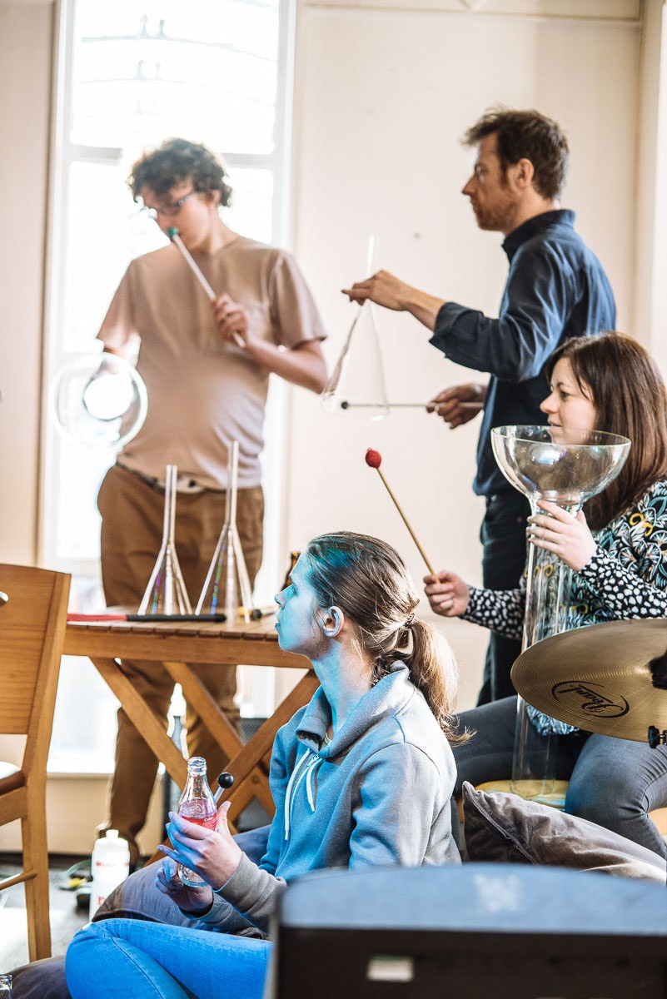
Malcy Duff
Allan Wright
Ceylan Hay
Sonia Allori
Nichola Scrutton
Sonic Bothy Ensemble
Adam Green
Andrew Robertson
Allan Wright
Sonia Allori
Ellen Phillips
Claire Docherty
Nichola Scrutton

About the Sonic Bothy Board
Sonic Bothy was constituted as a charity in 2015 and is in a period of expanding organisational capacity to meet its growing remit. We are expanding the board in order to provide a broader range of support to the organisation.
At present we have 6 Trustees:
- Chair
- Secretary
- Interim Treasurer
- Lead Trustee: Advocacy
- Lead Trustee: Policy and Guidance
- Lead Trustee: Data and Marketing

All trustees are volunteers who offer guidance and advice to the wider board and organisation’s team. In addition to its governance and leadership role, the board has responsibility for the support of the small staff team and to support change and new initiatives.
We are working actively to embed inclusion in our practice. We believe music and the arts are for everyone, regardless of age, disability, gender, marital status, maternity and pregnancy, race, religion, class and sexual orientation. Our approach to recruiting trustees is shaped by a commitment to diversity, equality and inclusion. With this aim we are committed to offering a flexible application process and flexible working practices.

