Sonic Bothy & Scottish Music Centre

Resound:

Scotland’s Inclusive Music Collection

Job Description: Freelance Researcher

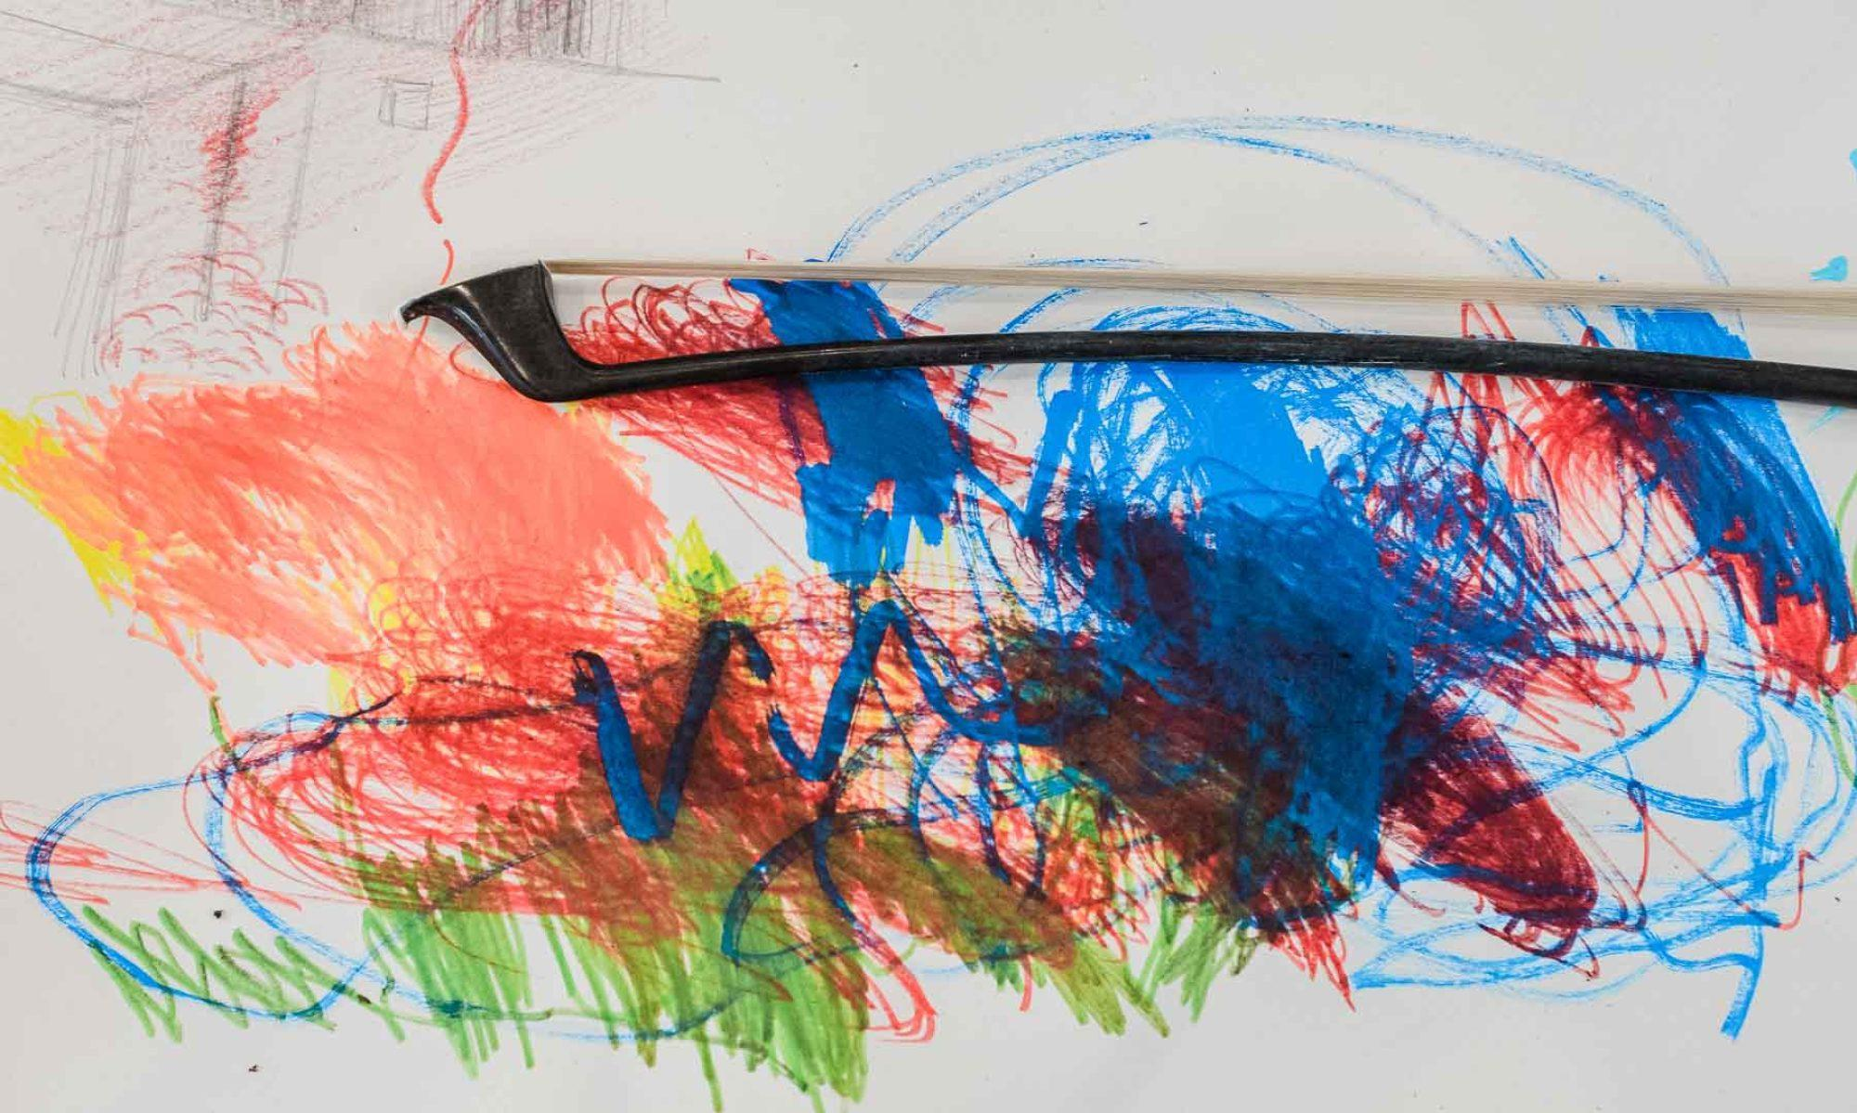

Image Credit: Brian Hartley

**Accessible Formats**

Clean text (Word doc)

Large text (Word doc)

Open Dyslexic font (PDF)

If you require information in a different format, please contact Sonic Bothy General Manager Christine Cooper [christine@sonicbothy.co.uk](mailto:christine@sonicbothy.co.uk)

Document Outline

About the Project 1

Role Overview 1

Key Responsibilities 2

Person Specification 3

How to Apply 3

Access and Enquiries 4

# About the Project

Sonic Bothy and the Scottish Music Centre (SMC) are developing a new digital archive to celebrate and document the work of contemporary Disabled music artists based in Scotland. Running from 2025 to 2028, the project will amplify the cultural contributions of Disabled artists, and embed inclusive practice within the Scottish music sector and beyond.

This project addresses the underrepresentation of Disabled artists within public collections and seeks to build a lasting legacy of visibility, advocacy and equity through a publicly available archive.

# Role Overview

Fee - £3,750 (£250 per day for 15 days work) plus Access Costs (if required)

Contract - Freelance, October 2025 to March 2026

Location - Primarily remote with occasional access-flexible, in-person meetings in Glasgow

We are seeking a freelance Researcher to carry out essential groundwork that will shape the scope, design and delivery of the Resound Scotland digital collection, which will be housed in the Scottish Music Centre’s archive. They will consult with artists, organisations and a newly-formed Disabled Artists’ Advisory Group to shape their research.

The researcher will produce a concise and accessible report (6-8 pages) that presents key findings and recommendations on the practical and inclusive development of the archive collection.

The suitable candidate will have demonstrable experience in community-based research, cultural projects or inclusive arts practice.

# Key Responsibilities

Research and Mapping:

* Map the current landscape of Disabled artist-led work, existing archives and similar initiatives across Scotland
* Detail the types of existing materials (e.g. audio, scores, film, graphic scores)
* Identify gaps, opportunities and the demand for this collection
* Document barriers faced by Disabled artists and audiences in accessing or contributing to archives, both in-person and online
* Consult directly with individuals and organisations, including those without formal archive systems.

Consultation and Engagement:

* Work with Sonic Bothy, SMC and the Disabled Artists’ Advisory Group to ensure the Resound collection is guided by consultation and inclusive practice
* Compile quotes and reflections from contributors where appropriate
* Attend occasional remote or in-person meetings (flexible to suit access needs)
* Update Sonic Bothy and the SMC at key points throughout the research.

Reporting and Recommendations:

* Produce a Recommendations Report (approx. 6-8 pages + appendices), including:
  + Summary of findings with clear, practical recommendations
  + Project scale and potential impact
  + Summary of existing formats (digital and/or physical)
  + Summary of suggestions from collaborators, networks and contributors
  + Collating feedback from organisations and communities
  + Existing access issues for Disabled artists and archive including online accessibility
  + Recommendations for the new archive’s accessibility and long-term use
* Collaborate with the Disabled Artists’ Advisory Group to reflect the lived experience of Disability in the project and the report
* Suggest effective, inclusive promotional strategies for the archive launch.

# Person Specification

Essential:

* Demonstrable experience in community-based research, cultural projects or inclusive arts practice
* Understanding of access, inclusion and the social model of Disability
* Familiarity with Scottish contemporary music, arts or cultural sectors
* Strong research, writing and communication skills
* Ability to work independently and meet deadlines
* Knowledge of digital collections, archiving or cultural policy.

Desirable:

* Lived experience of Disability, Neurodiversity or experience of Disability Advocacy
* Connections with Disabled artists and/or arts organisations in Scotland
* Experience working in partnership with community groups or advisory panels.

Timeline:

* Application Launch - Tuesday 2nd September
* Application Deadline - Wednesday 1st October at noon
* Interviews - w/c Monday 13th October 2025
* Work Duration - 15 days between November 2025 and March 2026
* First Draft Report - date TBC
* Final Report Due - Friday 27th March 2026.

# How to Apply

To apply, please submit:

* A CV (maximum two pages)
* A short cover letter (maximum one page) outlining your relevant experience, your interest in the role and how you would approach inclusive research practices
* Applicants are welcome to provide links to previous work or examples of similar projects.

We accept applications in written, video or audio format. If you would like to apply in another way or need this information in an alternative format, please email Sonic Bothy General Manager Christine Cooper at [christine@sonicbothy.co.uk](mailto:christine@sonicbothy.co.uk)

We offer flexible and accessible interview options.

# Access and Enquiries

If you have any questions or access needs regarding the application process, please contact:

Christine Cooper

General Manager, Sonic Bothy

[christine@sonicbothy.co.uk](mailto:christine@sonicbothy.co.uk)

We actively welcome applications from individuals who are Disabled, Neurodivergent, Black and people of colour, LGBTQ+, and people from working-class or low-income backgrounds. We are committed to equitable recruitment, fair freelance pay, and building inclusive, collaborative working environments.

Sonic Bothy and Scottish Music Centre are grateful for the support from the Creative Scotland Multi-Year Fund.



